Step 1 : Create index.html file

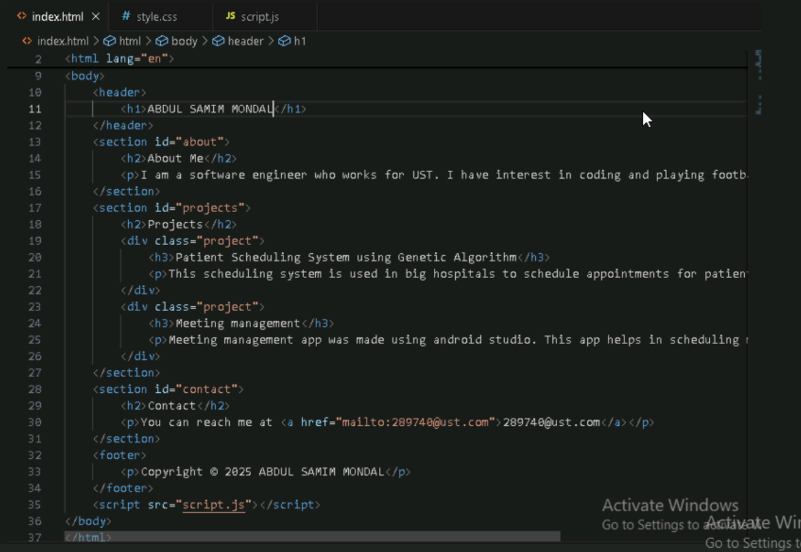

Step 2: create css file

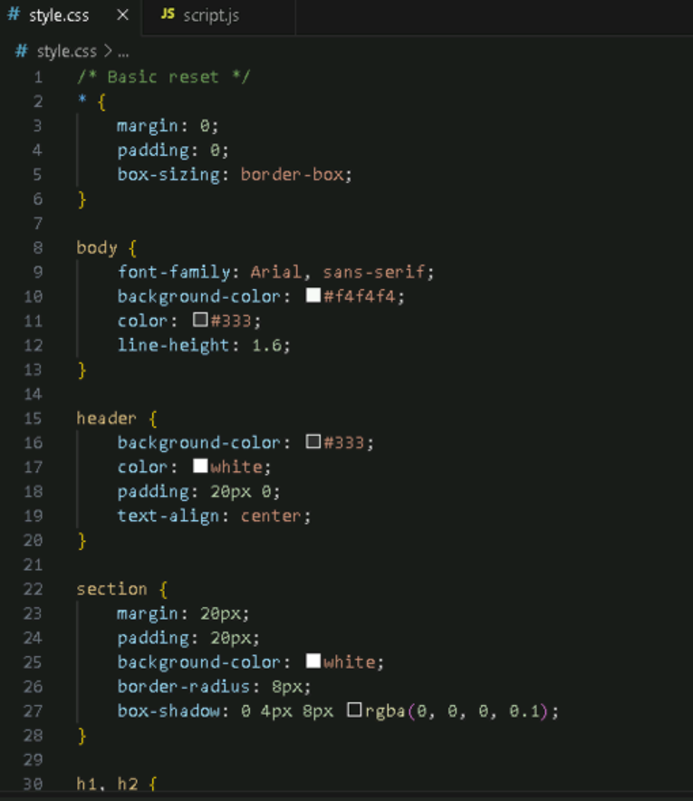

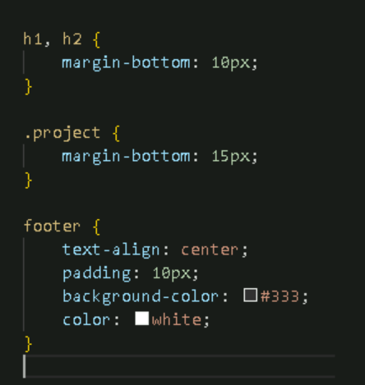

Step 3: create javascript file(optional)

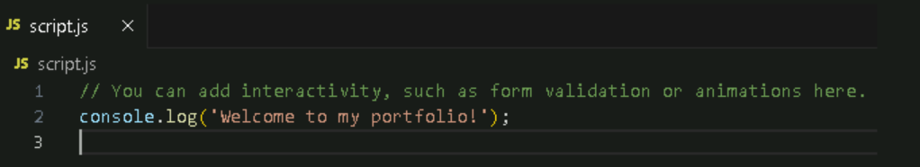

Step 4: Create a Git repository

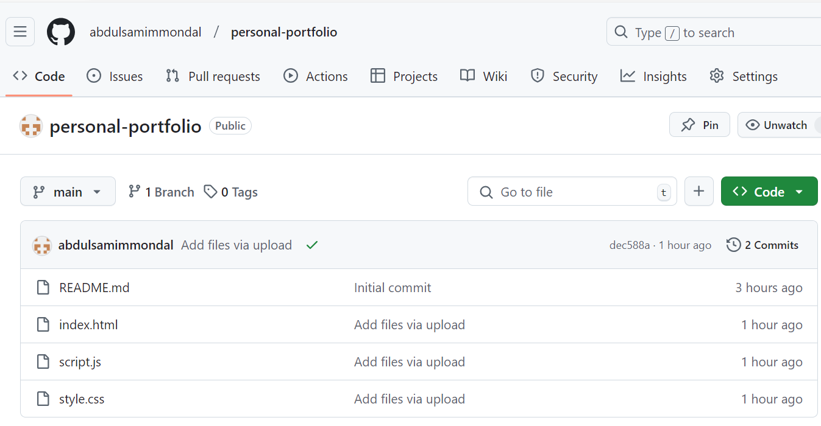

Step 5: initialize the local git repository

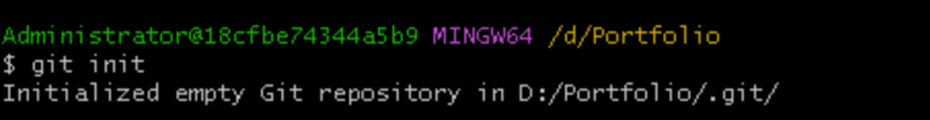

Step 6: add the files to the staging area, commit the changes and push them to github.

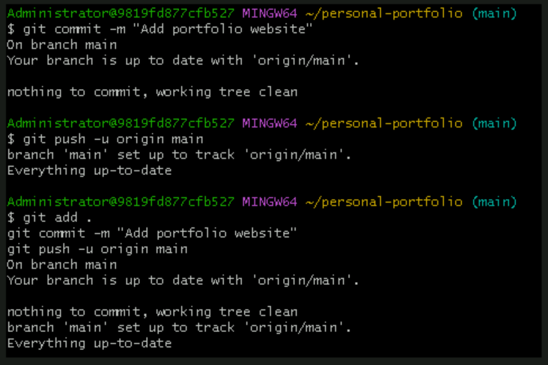

Step 7: host the website using pages.

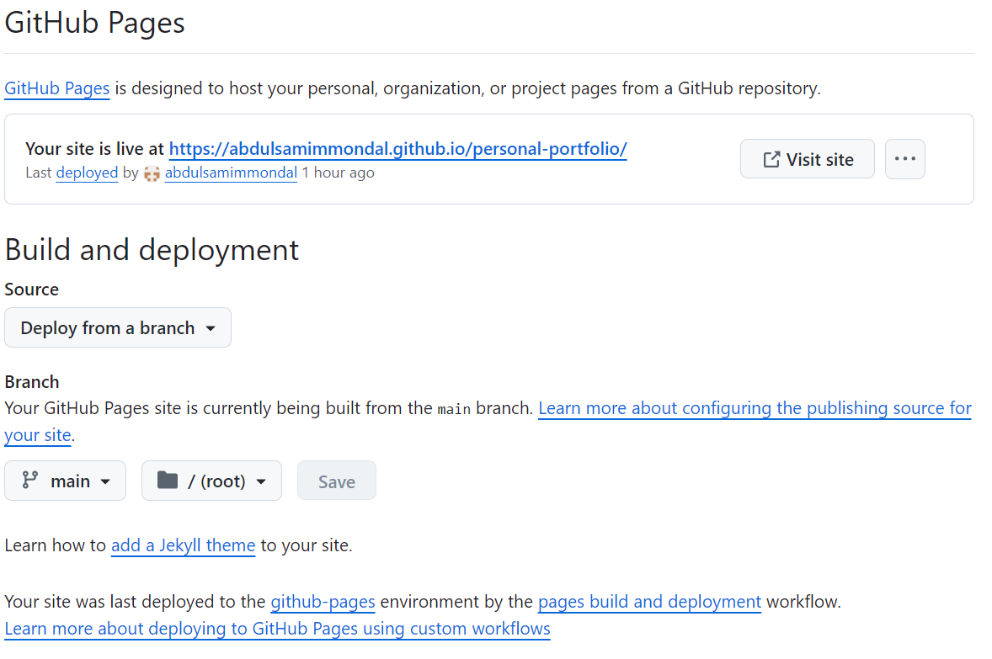

Website snap

